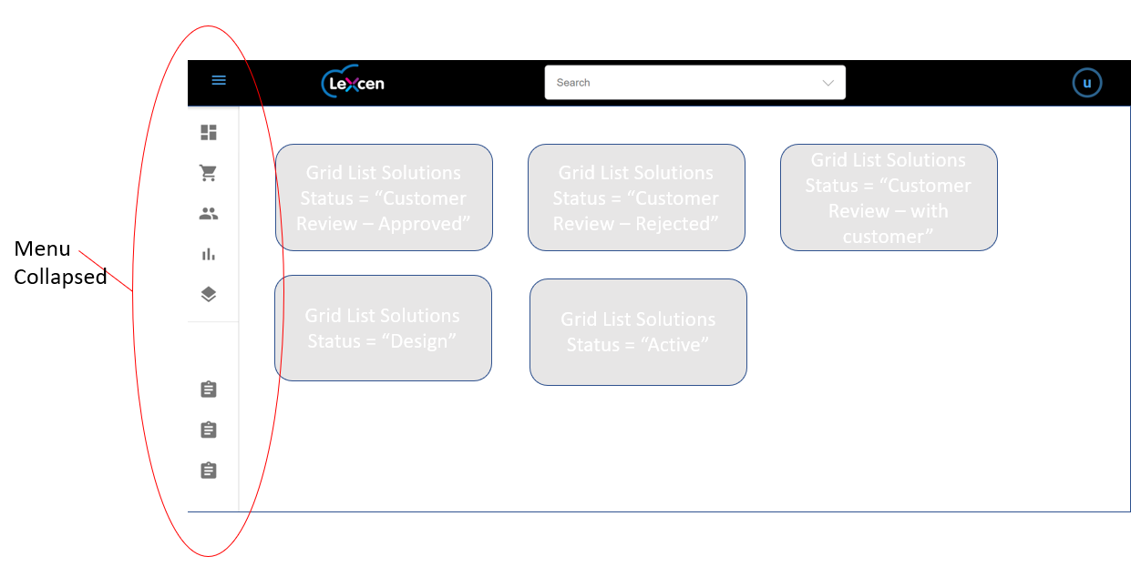
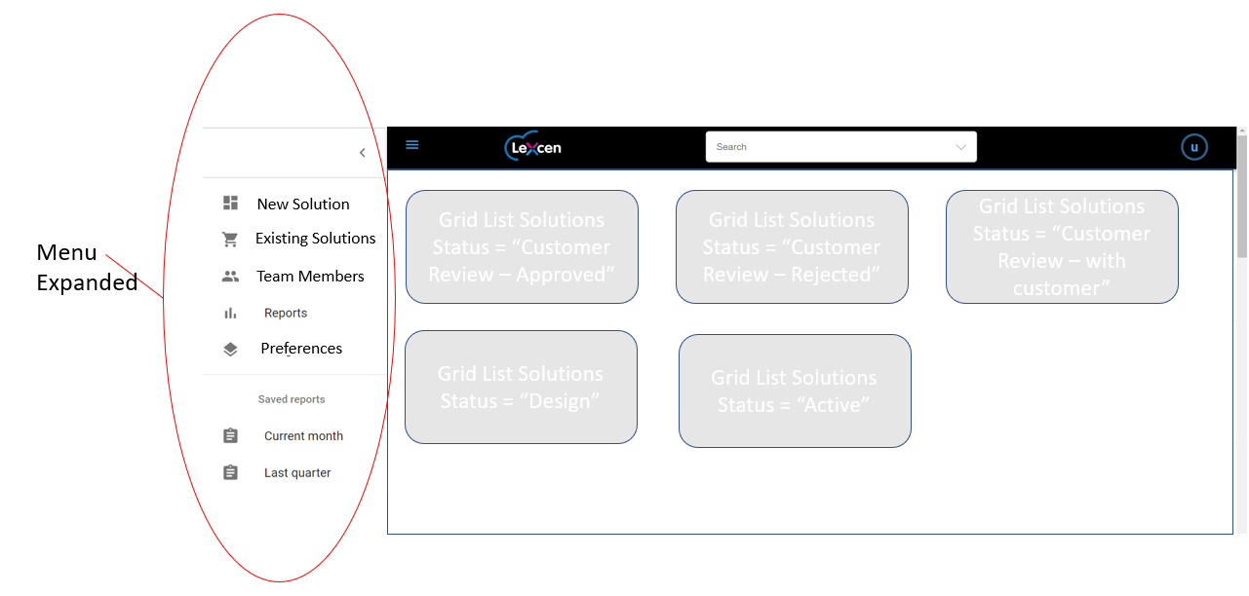
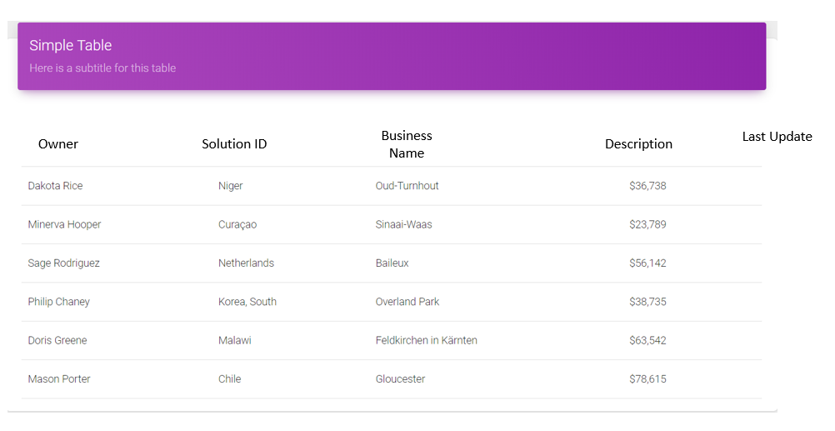
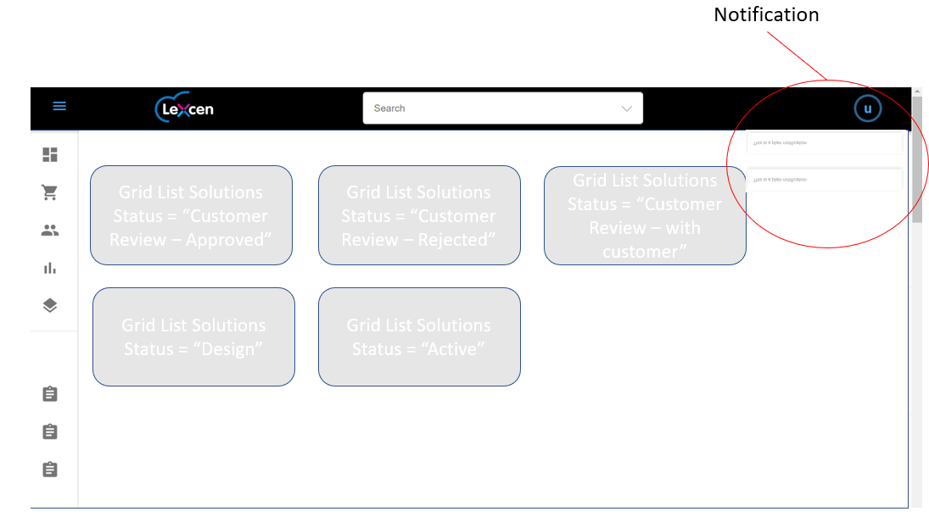
User Story

User has completed login and is presented with a dashboard as the next page seen. The dashboard will provide a quick view of what solutions are in each status, with a status represented in it’s own grid/table list as a dashboard item. Each table will display the newest 5 of that status based on the ‘updated time’ field. If a new status change occurs the user will be notified realtime through a notifications at the top right, under the banner.
Wireframe and description
Menu Collapsed:
Menu expanded:

Table/Grid List Example:

The fields used in the table should be Owner, Solution ID, Business Name, Description and Last Update (Updated at from dynmdoDB).

The client should subscribe to updates from the backend and be notified when any solution changes status. When an update is received the client should display a notification at the top right corner under the banner as follows

Notifications should include:
Solution ID
Time (from UpdatedAt field)
Status Updated To

There should be a “close all” under the notifications or each notification can be closed by the “X” on the top right hand side of the notification.

Components

The menu will be this component: https://material-ui.com/demos/menus/
Demo of style: https://material-ui.com/page-layout-examples/dashboard/
The Dashboard Grid list of solutions will use this component: https://demos.creative-tim.com/material-dashboard-react/?_ga=2.73211792.2018901131.1538643454-1975117925.1537408417#/table
For notifications: https://demos.creative-tim.com/material-dashboard-react/?_ga=2.73211792.2018901131.1538643454-1975117925.1537408417#/notifications
Both from this library: https://www.creative-tim.com/product/material-dashboard-react

Data and Software architecture requirements
All data should be pulled from GraphQL on page load and cached on clients side.
The client should subscribe to updates via graphql for determining when any solution has changed status.

